Society News

Your Society continues to be in a good position, with some 430 members and a stable bank balance. The profit from the events over last winter was some £2,020 and from events over this spring and summer £2,230 so far. As you will hopefully see from the events programme with this Newsletter, we continue to seek to balance more traditional events with some new ideas. We trust you approve, because all the profit from these events goes of course to supporting Fairfax House, which is why the Society was set up.

As your management committee for the Friends, we have awarded Honorary Membership status to Peter Brown, Gerry Webb and Judy Webb. Peter was previous Director of Fairfax House and very much involved in the restoration and promotion of the house as a major attraction known in the city and beyond. Gerry and Judy were custodians of the house and have both been on the committee for over thirty years. Among other roles, Gerry was former editor of this Newsletter and Judy was Events Secretary managing event bookings.

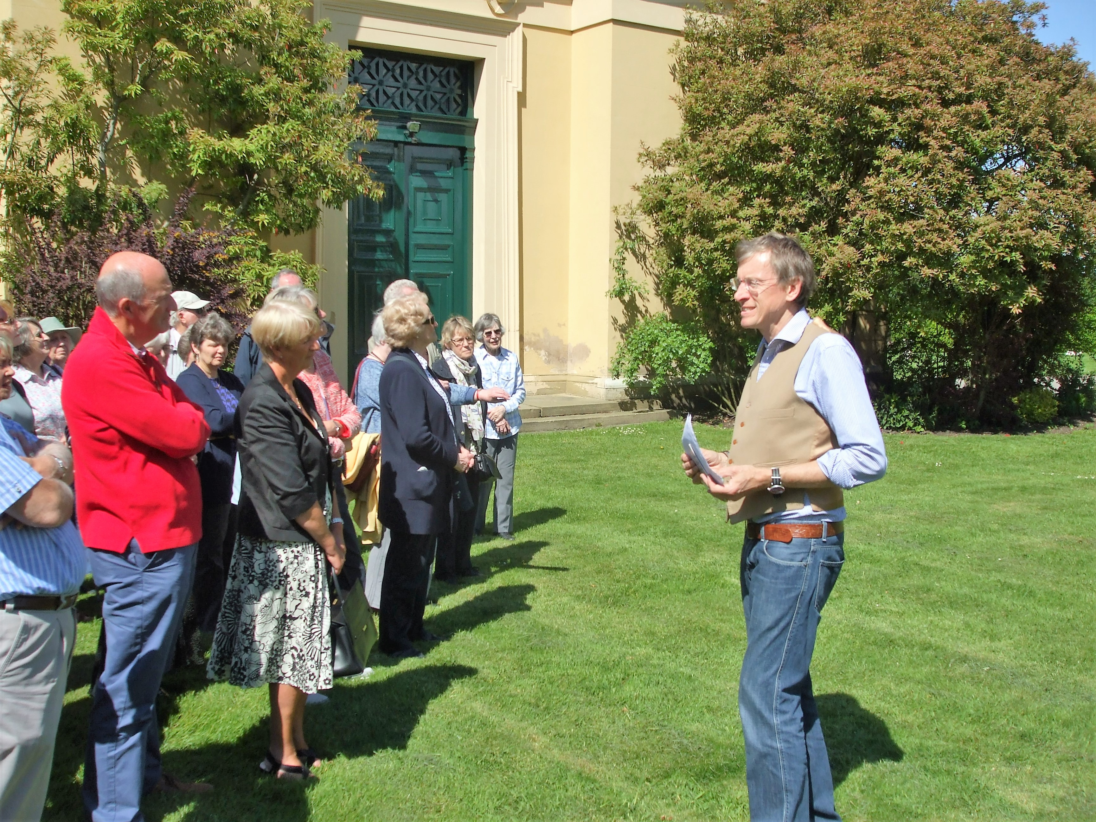
The Friends at Everingham, see page 3

We have also set up our first Friends of Fairfax House Memorial Studentship, appointing Estee O’Connor (an American and York University MA student) to spend one day a week for a year on research related to the house. For this first studentship the focus is on the 19th century history of the house, a period about which much more can be learned. We will of course pass on the highlights to you. We have received two generous bequests from former members Lesley Norris and Helen Wilkinson, and the studentship means their gifts are used in a special way.

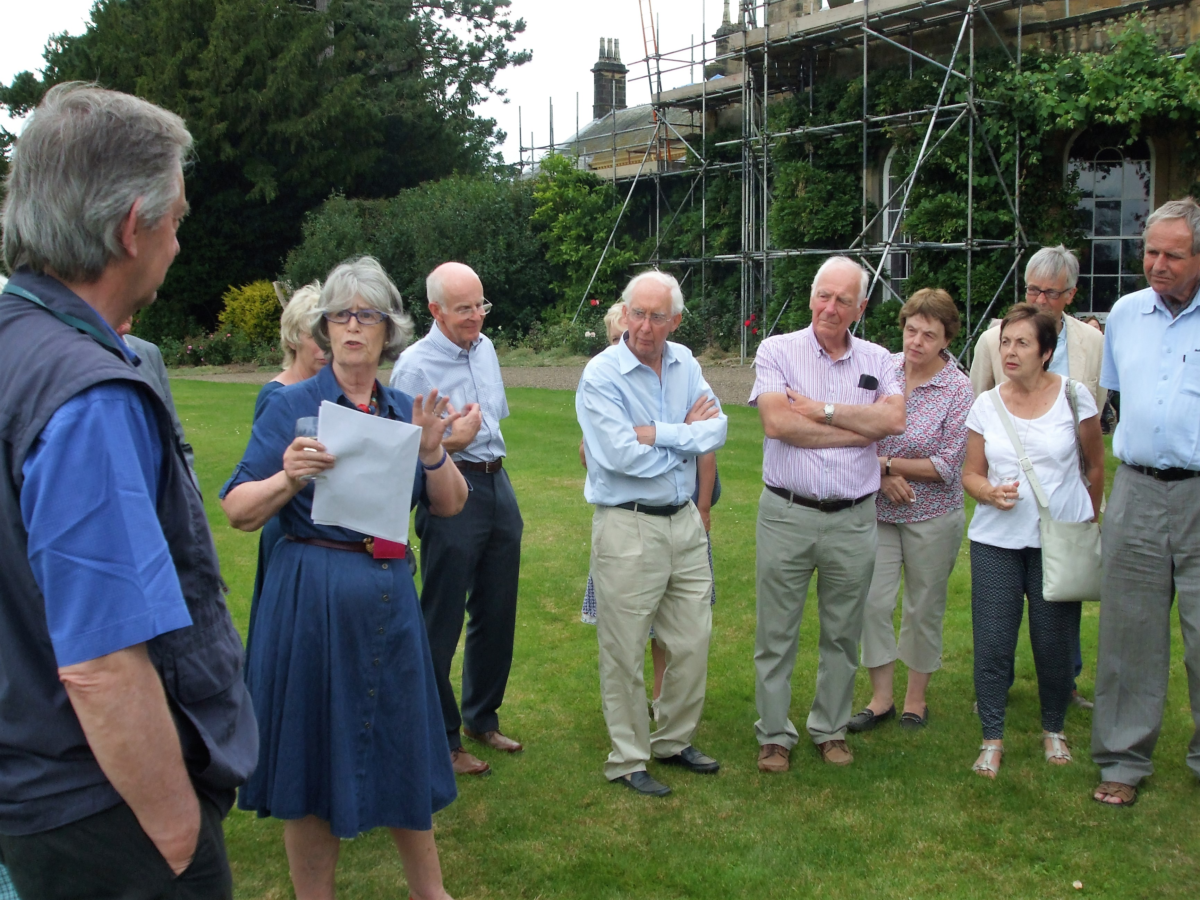
The Friends at Wykeham, see page 3

Some 65 of you attended the Annual General Meeting in April which was very heartening. We are required to have a meeting like this every year, and do try to keep the formal part as short as possible with, a talk afterwards. We hope to see you on Monday 10 April next year!

In this Newsletter we must pay tribute to the hard work over many years of the previous editor, Gerry Webb. I hope that we can continue his good work and to meet your approval as our members and readers.
Dates for your diary –
Upcoming events

Thursday 6 October 2016
Three Churches Visit with Tea
Cropton, Lastingham and Appleton-le-Moors
Start 1.30pm at Cropton church
Price £16 including afternoon tea
Guided visits to three interesting North Yorkshire churches, from early Christianity at Lastingham to the 19th century at Appleton-le-Moors (by J L Pearson) and Cropton. There will be a short talk at each and time to explore. At the end we will enjoy a light tea. Transport is by your own cars, and we will arrange lifts if possible. The price includes a donation to each church and the tea. We can provide directions on request and will guide you from Cropton on the day.

Wednesday 16 November 2016
Winter House Party
Fairfax House, Castlegate, York
7.30 to 10.00pm
Price £25 members (£25 non-members)
Our House Party will be a ‘Black Tie’ event on a 1920s theme, with entertainment featuring a close-up magician, music and songs of the day, a chance to try the Charleston plus a Blackjack table. There will be wine (or soft drinks) and delicious savoury and sweet delights. The party last year was popular with members and we hope that it will be equally as varied and lively an event this year. Tickets will be limited to the capacity of the house, so book early please.

Tuesday 28 February 2017
The History of Silver Hallmarking
Talk by Dr David Allen
St Michael le Belfry Hall, 52A Stonegate, York
2.30pm
Price £12 including afternoon tea
Dr David Allen, who has entertained us well with previous talks, will speak on the subject of Silver Hallmarking. He will illustrate his talk with examples of silver artefacts dating from the 17th to the 20th centuries. Hallmarking of silver has been used in the UK from the late 17th century and there was an Assay Office in York until 1858. Although the system is used in other countries, that of the UK is the most comprehensive and detailed. This promises to be a fascinating guide to a well-known topic.

Wednesday 15 March 2017
Some skeletons from Noel Terry’s closets: the perils and pitfalls of 20th century furniture collecting
Talk by Dr Adam Bowett
St Michael le Belfry Hall, 52A Stonegate, York
2.30pm
Price £12 including afternoon tea
Furniture expert Adam Bowett, who is currently working on an updated catalogue of the Fairfax House collection, will speak on furniture collecting in Noel Terry’s time. He will also focus on some of the more dubious pieces whose history may not be as good as Noel Terry believed! Many of us will think we know the house furniture collection and this will set things in a new perspective in some cases.

Monday 10 April 2017
Annual General Meeting and talk on
‘The Great Sculpture Collections of the Yorkshire Country Houses – a recent appraisal’ by Peter Brown MBE FSA
Friends Meeting House, Friargate, York
2.15 pm (tea/coffee from 1.45)
No charge
Our formal Annual General Meeting will last only about 25 minutes, to hear the year’s reports, approve accounts and confirm the society committee.
It will be followed by a talk by Peter Brown, former Fairfax House Director, taking a new look at the sculpture at some of our great country houses and setting their collection and purpose in a new light.

How to book events
Unless otherwise stated, our events are open only to fully subscribed society members.
You are asked to name any non-members you are bringing to the Winter House Party so we know who to expect.
When completing your cheque to Friends of Fairfax House please check you put the right amount in words and figures.
If any events you apply for are sold out then you will be contacted to arrange a refund of that part.
You will receive confirmation of your booking by e-mail (which we prefer please) or by post. No tickets will be issued.
If you have queries then please contact Buff Reid on 01904 631150.

Our 2017 Overseas Study Tour
The Great Palaces, Castles and Gardens of Mecklenburg-Vorpommern and the lake lands of northern Germany
Monday 15 to Tuesday 23 May 2017
Hannah Phillip (Fairfax House Director) is planning a tour for spring 2017 to northern Germany’s state of Mecklenburg-Vorpommern, known especially for its stunning lakes and scenery and rich array of dramatic palaces and historic architecture. This nine-day tour will have two centres in the state capital and historic city of Schwerin and Ulrichshusen in the heart of the lake district (three nights each place), plus two additional nights in Berlin in conclusion.
The tour will feature a full itinerary taking in the greatest of Mecklenburg’s glorious palaces, castles, houses and gardens (often still in private ownership) – many with strong 18th century connections. Highlights will include Mirow Palace (birthplace of King George III’s wife Queen Charlotte), the neoclassical Ludwigslust Palace (seat of the Dukes of Mecklenburg 1756-1837) with its English-style gardens, the palatial baroque manor-house Bothmer Castle, Hohenzieritz Palace with garden attributed to ‘Capability Brown’, the romantically turreted Schwerin Palace home of the state parliament and set in magnificent gardens on a lake, Güstrow Palace a marvel of Renaissance architecture, and Rheinsberg Palace built by Frederick the Great of Prussia.
We will visit the towns and cities of Wismar (Hanseatic trading port and World Heritage Site), the old town of Güstrow, the ducal seat of Neustrelitz known for its Baroque architecture, and Neuruppin, a Prussian town on the shore of Ruppiner Lake. There will be optional evening excursions to see the Britten opera ‘Peter Grimes’ and the musical ‘My Fair Lady’ by the Mecklenburg State Opera.
The tour will include entry to all sites, accommodation, most meals (all breakfasts plus some lunches and dinners) and airport transfers. Group air flights can also be arranged should you so wish. Flights will leave from Doncaster Sheffield Airport flying to Berlin for tour start (or where you may join the tour in Germany).
We will take a maximum of 25 people. Places will be allocated on a first come first serve basis. Full tour details and costs will be released shortly when a deposit will be required to secure your place.
For more details or to express interest please contact Hannah Phillip at Fairfax House – hannahphillip@yorkcivictrust.co.uk.
Events Review

Annual General Meeting
The Annual General Meeting (AGM) provided the usual chance to report back to society members on our progress and finances. The short formal meeting was followed by a talk by Dr Matt Jenkins of York University on domestic life and shopping in 18th century York. Dr Jenkins talk illustrated some of the relevant buildings in York and provided an interesting review of life in the time of Viscount Fairfax and his daughter.
The minutes of this AGM will be provided at the meeting next year (advertised above) and are available from our Secretary on request.

Everingham Hall
Our first summer visit was to Everingham Hall where we were guests of Mr and Mrs Phillip Guest who showed us around on a warm sunny day. Designed by John Carr and restored by Francis Johnson, both of whom of course worked on Fairfax House, Everingham is of similar date, being built in 1757-64 and restored about 1962. Most of the village church of St Everilda was rebuilt about 1763, possibly by John Carr who was working on the hall then. Looming over the hall is the huge and finely decorated Roman Catholic chapel, completed in 1839, and formerly used for services. It is an amazing building which would make a good concert venue. A future event maybe! We thought this trip (which concluded with tea and cake) would be of particular value to Fairfax House hosts, and it would have been good to see more hosts there.

Sion Hill Hall
In late June we had another good weather day for our visit to Sion Hill Hall, just north of Thirsk. It is a handsome neo-Georgian house built in 1913 by Walter Brierley, who worked at many places in Yorkshire – for example he designed Goddards in 1926-7 for Noel Terry. Sion Hill stands on a site previously occupied by a mansion of the Lascelles family. The very fine collection of furniture, porcelain and paintings was put together by Herbert Mawer who acquired the hall in 1963. The current owner, Michael Mallaby, is a trustee of the charity set up to preserve Sion Hill, and he has developed the collection further. There was also the opportunity to view the fine and extensive gardens, which have been restored to beautiful condition. It was a most interesting visit on a glorious day especially since Sion Hill Hall is only open for organised groups.
Scampston and Wykeham
We had another warm bright day for our July visit to Scampston Garden and Wykeham Priory. In Scampston we enjoyed a guided walk around the parkland designed by ‘Capability’ Brown and a look at the lovely modern garden alongside. This was created by the famous Dutch garden designer, Piet Oudolf, and features much of his style with for example drifts of swaying grasses. It was the perfect place for a lunchtime picnic in the sun and tea in the restaurant.
At Wykeham we were given a warm welcome by Diana, Lady Downe, who provided us with a tour of the main rooms of the house, its centre section built in the 18th century but extended and adapted in 1902. Much of the walled kitchen garden and areas alongside are now a mature plants nursery where we learned something of the business. The afternoon concluded with drinks and canapés on the terrace outside the house.
We much appreciated the support of Langleys, Solicitors of York, who kindly sponsored the bubbly and soft drinks which we enjoyed here at Wykeham. It was good that Nick Symington of Langleys was able to join us on the day.

Exclusive Exhibition Preview
From Exotica to Erotica: In Pursuit of Pleasure, the World of Georgian Entertainment
At the end of July we enjoyed another exclusive Friends’ exhibition preview. After drinks and nibbles, Hannah Phillip (Fairfax House Director) gave us an introduction to the new exhibition. She then provided a tour of the exhibits, explaining the background and highlighting items. It was a fascinating insight into the varied world of 18th century pleasures, from the polite to the bawdy. Opera, theatre and music stood alongside cock-fighting, prize-fight boxing and public hangings. With the opportunity also to discuss exhibits, it was a special chance to explore the varied world outside Viscount Fairfax’s front door!

Capability Brown and the Yorkshire Landscape
A visit to the Mercer Art Gallery for a talk by Karen Lynch, Chairman of the Yorkshire Gardens Trust, and exhibition view is due on 8 September as this Newsletter is in production.

***
Please note that Friends may receive details of Fairfax House events both by post and e-mail. These are distinct from our Friends events and are booked separately.
Membership News

Since our last Newsletter in March, we have welcomed these new members:
Mr and Mrs A Boyle of York
Mr and Mrs D Brewster of Salton
Ms L Burn of York
Mrs Hellebrand of Preston
Mrs M Hodgson of Malton
Mr N Mullan of London
Mr and Mrs J Siddall of Great Ouseburn
Mr and Mrs G Tillotson of Filey
Mrs E Willcox of Lincoln

We have been sorry to say goodbye to:
Mr A Ainsworth of York
Mrs P Barker of York
Mrs E Cope of York

As explained above, Honorary Membership has been awarded to:
Peter Brown MBE FSA
Gerry Webb
Judy Webb

We have a life member, Miss G M Blanshard formerly of Aldersyde Court, York, with whom we have lost contact. If any reader knows her then we would welcome any news you have.

Subscriptions will become due on 1st January. Remember the current rate is £12 individual and £18 joint membership. Also please be aware that membership will cease if subscriptions have not been paid by 31st March 2017.

The other request is that you should make sure that we have your current e-mail address. This is essential if you want to be sure of receiving up-to-date information. We can no longer send out reminders, changes of plan and so on by ordinary mail, as the cost is now prohibitive.

David Yates
Editor

